### **Blockchain and crypto currency**

### **Aim**

The aim of this report is to provide a comprehensive analysis of blockchain and cryptocurrency metrics from 2020 to 2024. By examining key indicators such as transaction volumes, network fees, cost savings, user adoption rates, market capitalization, security incidents, and regulatory compliance, the report seeks to uncover trends, efficiencies, and challenges within the blockchain ecosystem. The goal is to offer actionable insights for stakeholders to enhance operational efficiency, ensure regulatory compliance, and optimize investment strategies. Ultimately, the report aims to highlight the transformative potential of blockchain technology and cryptocurrencies in the financial sector.

**Features**

1 Block chain transactions - Visualizes the trend of blockchain transactions over time, showing periods of increased or decreased activity.

2. Blockchain network fees- Highlights variations in transaction fees across different time periods, indicating network congestion or efficiency.

3.cost savings from blockchain - Illustrates cumulative cost savings achieved through blockchain implementation over time.

4.cryptocurrency trading volumes - Displays trading activity levels, highlighting periods of high or low market liquidity.

5.user adoption rates - Tracks the growth of user adoption of blockchain technology, indicating market penetration.

6.market Capitalization - Compares the market value of different cryptocurrencies, showing relative sizes and dominance.

7.security incident rates- Shows the frequency of security issues, helping to assess the network's integrity.

8.regulatory compliance incident - Breaks down the types and proportions of regulatory compliance issues within the blockchain ecosystem

9. Transaction confirmation time- Displays the distribution and variability in transaction confirmation times, indicating network performance and

**Methodology**

* Data collection and clearing data
* The methodology involves collecting monthly data from 2020 to 2024 on key blockchain and cryptocurrency metrics.
* Using statistical tools, we generate visualizations such as line charts, bar charts, area charts, and pie charts. These graphs are analyzed to identify trends, variations, and insights.

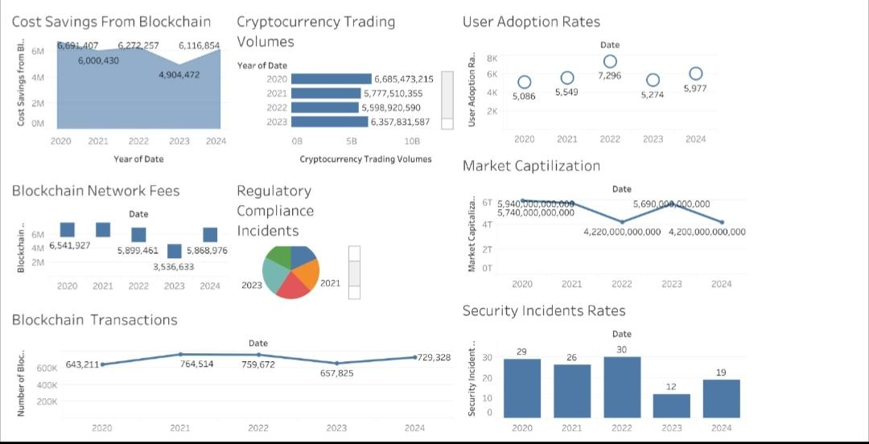**Output**

### **Result Analysis**

### 1. Blockchain Transactions - Line Chart

A line chart depicting blockchain transactions over time reveals trends and fluctuations in the number of transactions processed. By analyzing the peaks and troughs, stakeholders can identify periods of high activity and potential stress points in the network. This metric helps in understanding user engagement and network scalability.

### 2. Blockchain Network Fees -

A square highlight table visualizing blockchain network fees provides a clear, color-coded view of fee variations over time. Higher fees may indicate periods of network congestion or increased transaction demand, while lower fees suggest reduced activity or efficient network performance. This visualization helps in monitoring cost efficiency for users.

### 3. Cost Savings from Blockchain

An area chart showing cost savings from blockchain illustrates the cumulative benefits over time. This visualization highlights the financial impact of blockchain implementation, showcasing how it reduces operational costs compared to traditional methods. Stakeholders can see the growth in savings and justify continued investment in blockchain technologies.

### 4. Cryptocurrency Trading Volumes

A bar chart displaying cryptocurrency trading volumes helps in understanding the market dynamics and trading activity levels. By comparing volumes across different time periods, one can identify trends, peak trading times, and the overall health of the cryptocurrency market. This metric is crucial for investors and analysts monitoring market liquidity.

### 5. User Adoption Rates

A line circle chart for user adoption rates shows the percentage of users adopting blockchain technology over time. This visualization helps in tracking the growth of user engagement and acceptance of blockchain solutions. It provides insights into market penetration and the effectiveness of outreach and education efforts.

### 6. Market Capitalization

A circle packed bubbles chart for market capitalization visualizes the relative sizes of different cryptocurrencies in terms of their total market value. This interactive chart helps in comparing the market dominance and growth of various cryptocurrencies, providing a quick overview of market leaders and emerging players.

### 7. Security Incident Rates

A bar chart for security incident rates shows the frequency of security issues within the blockchain network. This visualization helps in identifying periods of vulnerability and assessing the effectiveness of security measures. Monitoring incident rates is crucial for maintaining network integrity and user trust.

### 8. Regulatory Compliance Incidents -

A pie chart illustrating regulatory compliance incidents breaks down the proportion of different types of compliance issues. This visualization helps in understanding the regulatory challenges faced by the blockchain industry and identifying areas that require attention to meet legal standards. It provides a clear overview of compliance status.

**Summary**

This project involves generating and interpreting various graphs related to blockchain and cryptocurrency metrics from 2020 to 2024. The metrics include blockchain transactions, network fees, cost savings, trading volumes, user adoption rates, market capitalization, security incidents, regulatory compliance, and transaction confirmation times. The visualizations provide valuable insights into the performance, trends, and challenges of blockchain and cryptocurrency usage.

For instance, the line chart of blockchain transactions highlights user engagement over time, while the square highlight table of network fees reveals fee variations, indicating periods of network congestion. The area chart for cost savings illustrates the financial benefits of blockchain implementation, and the bar chart for trading volumes shows market activity levels. Other visualizations, such as the circle packed bubbles for market capitalization and the pie chart for regulatory compliance incidents, offer comparative and proportional views. Overall, these visualizations help stakeholders understand and optimize blockchain and cryptocurrency operations